The testing of MongoDB begins by the creation of a new database “jamesdb”, this is achieved by simply switching to it in the mongo shell, using the command “use <insert database name>”. Next two documents are created in the database and then inserted into a collection “big1”, this collection is created simply by using the command db.<insert collection name>.insert( <insert document name> ), next by using a for loop a substantial amount of test data is inserted in the “big1” collection to be tested at a later date. For testing purposes more collections are created with substantial test data inside but this adequately demonstrates the process of creating the database to hold a substantial amount of test data.

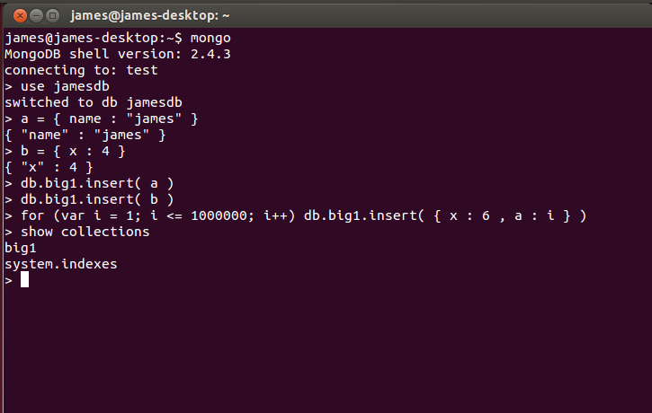

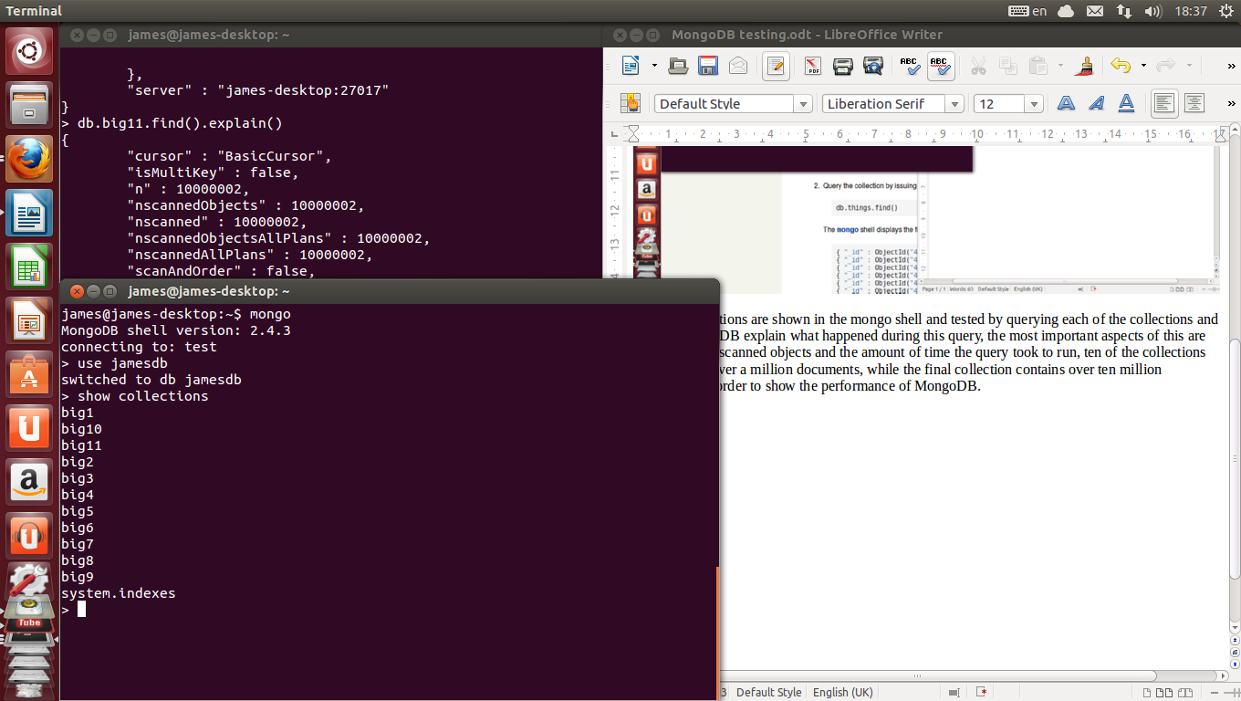
Next all collections are shown in the mongo shell and tested by querying each of the collections and having MongoDB explain what happened during this query, the most important aspects of this are the number of scanned objects and the amount of time the query took to run, ten of the collections each contain over a million documents, while the final collection contains over ten million documents in order to show the performance of MongoDB.



